**SENTIMENTAL ANALYSIS FOR MARKETING**

**Phase 5 Submission Document**

**Project Title : Sentimental Analysis For Marketing**

**Phase 5 : Project Documentation & Submission**

**Topic : In thish section we will document the complete project and prepare it for submission**

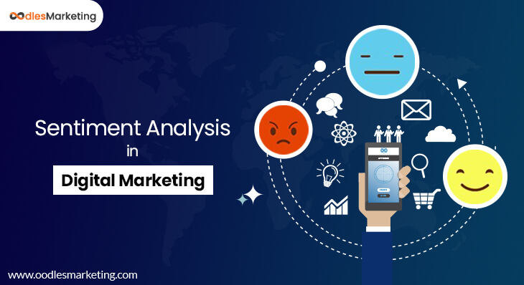

Introduction :

Sentimental analysis is an extremely useful tool to have since higher numbers of interactions don't always equate to better results. For example, if you were to receive 10 replies on a social post and all of them were positive, your post likely had a more compelling effect on your audience than if you receive 100 replies with only 10 of them being positive. The primary purpose of sentiment analysis is to respond to commentary more constructively

With the widespread usage of social networks, many people participate in the information distribution ihe web environment [1], [2], [3]. Users share opinions about products by providing textual reviews. These opinions emerged as a critical factor of future consumer purchasing decisions [4], [5], [6]. With the increasing popularity of network and intelligent mobile devices, the mode of network communication has changed from users’ passively receiving information transmitted by website operators to users’ sending out various information generated by themselves. Such information with emotional opinions has a certain degree of influence on business enterprises, politics, and even individuals [7], [8]. Nowadays, consumers are used to web search engines finding product usage evaluations, usage experiences, etc.

Contextual Semantic Search(CSS)

Now this is where things get really interesting. To derive actionable insights, it is important to understand what aspect of the brand is a user discussing about. For example: Amazon would want to segregate messages that related to: late deliveries, billing issues, promotion related queries, product reviews etc. On the other hand, Starbucks would want to classify messages based on whether they relate to staff behavior, new coffee flavors, hygiene feedback, online orders, store name and location etc. But how can one do that?

We introduce an intelligent smart search algorithm called Contextual Semantic Search (a.k.a. CSS). The way CSS works is that it takes thousands of messages and a concept (like Price) as input and filters all the messages that closely match with the given concept. The graphic shown below demonstrates how CSS represents a major improvement over existing methods used by the industry.

**Definition:**

Many businesses use social media channels for customer service support because it lets them resolve issues in a personalized yet immediate way. Responding to negative comments can help de-escalate situations before they grow into something less manageable. For example, if a customer were to tag your brand in a post in which they're upset about a defective product, you can respond publicly to apologize. You can then follow up by messaging them privately to reinforce your commitment to quality. Handling negative sentiments effectively and publicly can also show other customers that the company has excellent service policies.

With the development of Internet technology and the digital market in China, consumption through e-commerce platforms and giving online reviews after purchase have become mainstream. However, current market research still uses traditional methods of surveys and questionnaires, which largely influences the efficiency of relevant enterprises in finding key product issues and lowers new product performance. This paper conducts the aspect-based sentiment analysis (ABSA) method to study the impact of consumer sentiment involvement (CSI) on new product performance. We took the ceramic industry as a case study, and collected 3.22 million consumer responses for ABSA. A total of 22 performances of new products were analyzed for CSI hypothesis testing. We found that CSI big data analytics were positively related to new product performance and enterprise innovation.

For product evaluations to be searched, the purpose of this study is to automatically classify review articles into marketing 4Cs and non-marketing from a large number of consumer reviews and then to analyze emotional polarity according to different attribute aspects of marketing 4Cs, of which the attribute aspects are divided into 4 categories according to the marketing theory of 4Cs. In addition, this study establishes a feature keyword library belonging to a specific field, hoping to improve the process of consumers searching for product evaluations through these experiments, enhance the accuracy of sentiment analysis, and facilitate consumers to search for helpful target information. Moreover, the topics discussed by netizens will differ slightly in different time ranges, so the corpus collected will also produce diverse topics.

he highest valued start-up in the world, has been a pioneer in the sharing economy. Being operational in more than 500 cities worldwide and serving a gigantic user base,

Uber gets a lot of feedback, suggestions, and complaints by users. Often, social media is the most preferred medium to register such issues. The huge amount of incoming data makes analyzing, categorizing, and generating insights challenging undertaking.

We analyzed the online conversations happening on digital media about a few product themes: Cancel, Payment, Price, Safety and Service.

For a wide coverage of data sources, we took data from latest comments on Uber’s official Facebook page, Tweets mentioning Uber and latest news articles around Uber. Here’s a distribution of data points across all the channels**:**

Facebook: 34,173 Comments

Twitter: 21,603 Tweets

News: 4,245 Articles

Analyzing sentiments of user conversations can give you an idea about overall brand perceptions. But, to dig deeper, it is important to further classify the data with the help of Contextual Semantic Search

**PROGRAM :**

#### 1. ax = df['Rate'].value_counts().sort_index() \

#### .plot(kind='bar',

#### title='Count of Reviews by Stars',

#### figsize=(10, 5))

#### ax.set_xlabel('Review Stars')

#### plt.show()

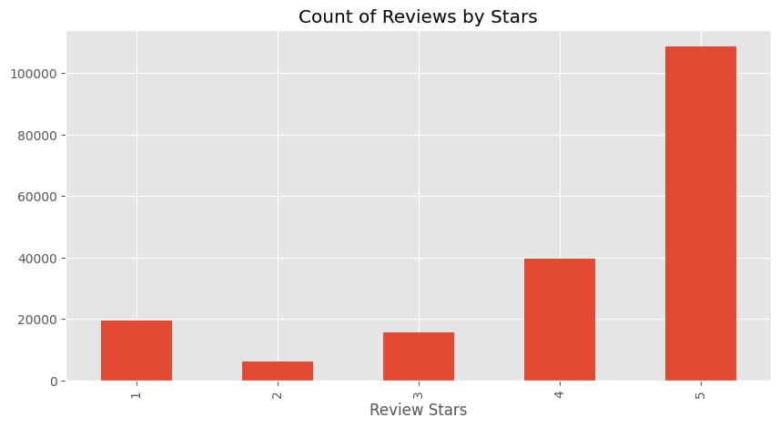

# ****# Distribution of User Rating****

# ****plt.figure(figsize=(10, 6))****

# ****sns.histplot(data['User Rating'], kde=True)****

# ****plt.title('Distribution of User Rating')****

# ****plt.xlabel('User Rating')****

# ****plt.ylabel('Frequency')****

# ****plt.show()****

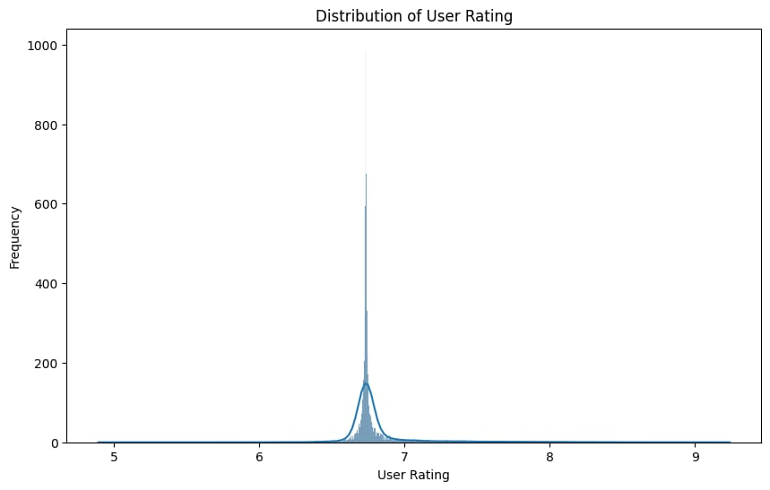

## **anime_index = indices["Legendary Idol Eriko"]**

# **cosine_sim[anime_index]**

# **similarity_scores = pd.DataFrame(cosine_sim[anime_index],**

# **columns=["score"])**

# **anime_indices = similarity_scores.sort_values("score", ascending=False)[1:11].index**

# **df['Title'].iloc[anime_indices]**

**Output:**

070 Ookami shoujo to kuro ouji

11179 Pokémon

16615 Ayashi no Ceres

38590 Durarara!!x2

19292 Kaguya-sama: Love is War

23338 To Your Eternity

36712 Free!

5194 Uta no Prince Sama Maji Love Kingdom, The Movie

6072 Dropout Idol Fruit Tart

6207 Kaginado

Name: Title, dtype: object

# 2. import operator

# wordcount = sorted(wordcount.items(), key = operator.itemgetter(1))

# wordcount.reverse()

# %matplotlib inline

# import matplotlib.pyplot as plt

# #plotovanie 10 najviac pouzivanych slov

# wordcount = wordcount[2:] #prve slova '' a 'rt' co mozme preskocit

# top10 = wordcount[:10]

# top10_words = [word for (word,count) in top10]

# top10_freq = [count for (word,count) in top10]

# indexes = np.arange(len(top10_words))

# width = 0.7

# plt.figure(figsize=(15,15))

# plt.bar(indexes, top10_freq, width)

# plt.xticks(indexes + width/2 , top10_words)

# plt.show()

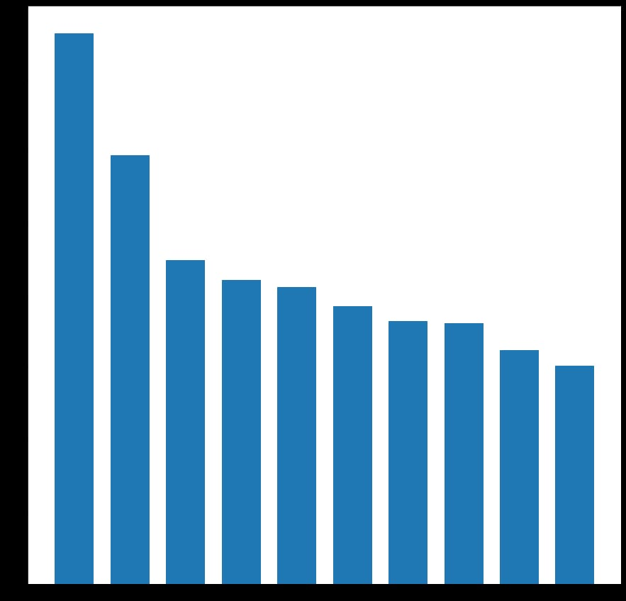

# tweets['tweet_subjects'] = [tweet_subject(tweet) for tweet in tweets['tweets']]

# #najčastejši predmet

# all_subjects = [word for wordlist in tweets['tweet_subjects'] for word in wordlist]

# all_subjects_counts =dict([(word,all_subjects.count(word)) for word in set(all_subjects) ])

# all_subjects_counts = sorted(all_subjects_counts.items(), key = operator.itemgetter(1))

# all_subjects_counts.reverse()

# print('TOTAL UNIQUE SUBJECTS : ', len(all_subjects_counts))

# for (a,b) in all_subjects_counts[:30]:

# print(a,b)

**Output:**

# TOTAL UNIQUE SUBJECTS : 29037

# https 9224

# @ 7498

# rt 5841

# isis 2324

# amp 1312

# syria 1011

# army 896

# state 706

# i 594

# ramiallolah 567

# today 549

# soldiers 520

# forces 482

# city 464

# people 430

# attack 421

# aleppo 409

# assad 379

# fighters 359

# iraq 350

# rebels 344

# … 338

# amaqagency 336

# allah 326

# al 323

# video 320

# nidalgazaui 312

# muslims 305

# regime 303

reports 277

We introduce an intelligent smart search algorithm called Contextual Semantic Search (a.k.a. CSS). The way CSS works is that it takes thousands of messages and a concept (like Price) as input and filters all the messages that closely match with the given concept. The graphic shown below demonstrates how CSS represents a major improvement over existing methods used by the industry.

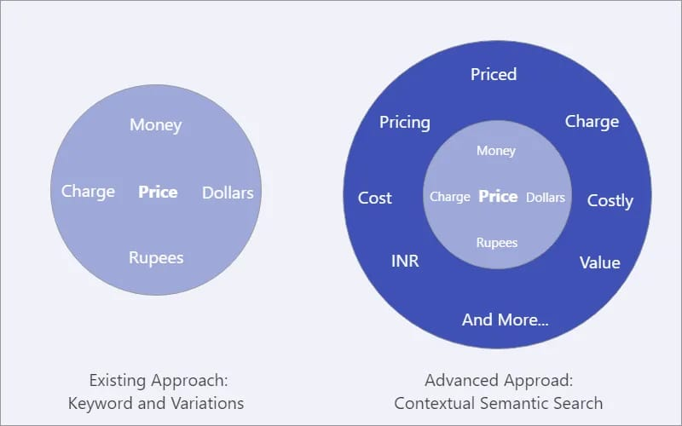

FACEBOOK

Sentiment Analysis:

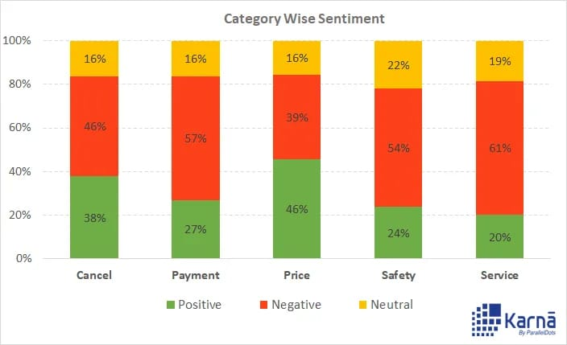

Noticeably, comments related to all the categories have a negative sentiment majorly, 0bar one. The number of positive comments related to Price have outnumbered the negative ones. To dig deeper, we analyzed intent of these comments. Facebook being a social platform, the comments are crowded random content, news shares, marketing and promotional content and spam/junk/unrelated content. Have a look at the intent analysis on the Facebook comments:

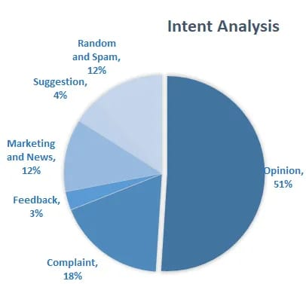

TWITTER

Sentiment Analysis:

A similar analysis was done for crawled Tweets. In the initial analysis Payment and Safety related Tweets had a mixed sentiment.

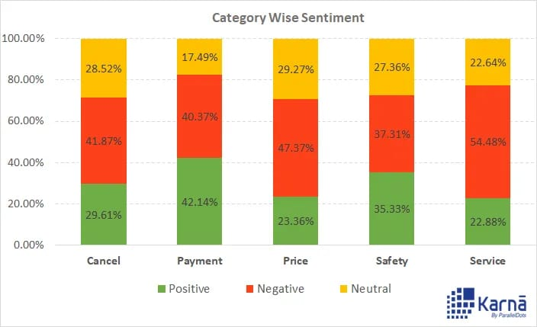

To understand real user opinions, complaints and suggestions, we have to again filter the the unrelated Tweets(Spam, junk, marketing, news and random)

There is a remarkable reduction in number of positive Payment related Tweets. Also, there is a significant drop in the number of positive Tweets for the category Safety(and related keywords.)

Additionally, Cancel, Payment and Service (and related words) are the most talked about topics in the comments on Twitter. It seems that people talked most about drivers cancelling their ride and the cancellation fee charged to them. Have a look at this Tweet

NEWS:

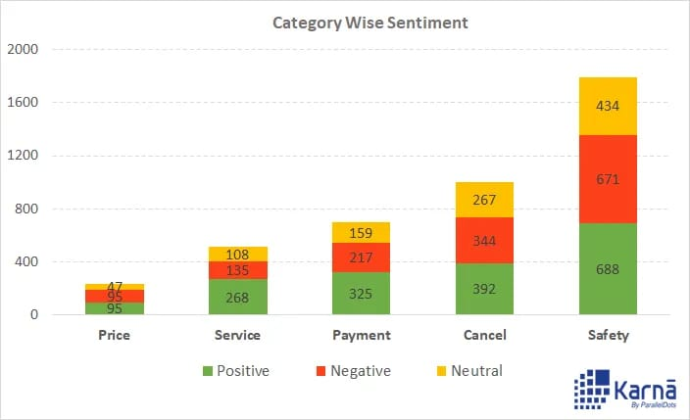

**Understandably so, Safety has been the most talked about topic in the news. Interestingly, news sentiment is positive overall and individually in each category as well.**

**We classified news based on their popularity score as well. The popularity score is attributed to the share count of the article on different social media 0channels. Here’s a list of top news articles**

contextual Semantic Search(CSS)

Now this is where things get really interesting. To derive actionable insights, it is important to understand what aspect of the brand is a user discussing about. For example: Amazon would want to segregate messages that related to: late deliveries, billing issues, promotion related queries, product reviews etc. On the other hand, Starbucks would want to classify messages based on whether they relate to staff behavior, new coffee flavors, hygiene feedback, online orders, store name and location etc. But how can one do that?

We introduce an intelligent smart search algorithm called Contextual Semantic Search (a.k.a. CSS). The way CSS works is that it takes thousands of messages and a concept (like Price) as input and filters all the messages that closely match with the given concept. The graphic shown below demonstrates how CSS represents a major improvement over existing methods used by the industry.

Sentiment analysis of marketing involves assessing the emotional responses and perceptions of customers and the general public towards marketing efforts, campaigns, and strategies. The sentiment can be positive, negative, or neutral. Here's a breakdown:

Positive Sentiment:

Positive sentiment in marketing is an indication that customers and the audience are responding favorably to marketing campaigns.

It often means that the message, product, or service is resonating with the target audience, leading to increased brand loyalty and sales.

Examples of positive sentiment include glowing reviews, social media praise, and high customer satisfaction scores.

Negative Sentiment:

Negative sentiment signifies that there is disapproval, dissatisfaction, or controversy surrounding marketing efforts.

It can damage a brand's reputation and lead to decreased sales and customer churn.

Negative sentiment might arise from advertising that is perceived as insensitive or deceptive, product issues, or poor customer service.

Neutral Sentiment:

Neutral sentiment means that the audience is neither overwhelmingly positive nor negative about a marketing campaign.

It could indicate that the campaign did not strongly impact the audience's emotions.

While neutral sentiment might not be ideal, it's not necessarily detrimental either. It could mean that the campaign didn't provoke strong reactions.

Measuring Sentiment:

Sentiment analysis can be done through various tools and techniques, including natural language processing (NLP) algorithms and social media monitoring.

It involves analyzing text data from sources like social media posts, reviews, surveys, and comments to gauge sentiment.

Sentiment analysis can also provide insights into specific aspects of marketing, helping brands identify what works and what needs improvement.

Using Sentiment Analysis in Marketing:

Marketers can use sentiment analysis to refine their strategies, tailor messaging, and respond to customer feedback.

It can help in crisis management by identifying negative sentiment early and addressing concerns.

Brands can also leverage positive sentiment for testimonials, user-generated content, and reinforcing brand reputation.

Challenges:

Sentiment analysis may have limitations, such as difficulty in understanding sarcasm or irony.

Cultural and linguistic nuances can affect the accuracy of sentiment analysis.

Context is crucial, as a single word can have different sentiments in different contexts.

In summary, sentiment analysis is a valuable tool in marketing to gauge public perception, make data-driven decisions, and enhance customer experiences. It helps marketers adapt and optimize their strategies to maintain or improve their brand's image and ultimately drive success.

entiment analysis of marketing can be both positive and negative, depending on various factors.

Positive sentiments in marketing often arise when:

Customers appreciate creative and authentic advertising campaigns that resonate with their values and emotions.

Products or services fulfill or exceed customer expectations, leading to positive word-of-mouth and reviews.

Brands engage with customers effectively on social media and respond to their needs promptly.

Marketing efforts are seen as informative and valuable rather than intrusive.

Negative sentiments in marketing typically arise when

Customers feel overwhelmed or annoyed by excessive advertising, spam emails, or intrusive pop-up ads.

Brands fail to deliver on their promises, leading to dissatisfaction and negative feedback.

Marketing messages are misleading or manipulative, eroding trust in the brand.

Companies mishandle customer data or engage in unethical practices, damaging their reputation.

Effective marketing strategies aim to cultivate positive sentiments by focusing on customer satisfaction, building trust, and delivering value. Negative sentiments can be mitigated through ethical and transparent practices and by actively listening to customer feedback.

**Conclusion:**

Sentiment analysis is a marketing tool that helps you examine the way people interact with a brand online. This method is more comprehensive than traditional online marketing tracking, which measures the number of online interactions that customers have with a brand, like comments and shares.

Social websites available over the Internet help users in predicting future events. User preferences over the web are in the form of blogs, textual content, public forum discussion and social media. However, reading informal discussions impact the users in the global market. In this paper we have proposed an SVM based classification method which assists the users to make informed transactions. Classifier makes use of the information available in the social media to make correct decision in the market. Our approach is compared with the traditional human based prediction approach and the results indicate that the classifier based prediction approach produces higher accuracy in terms of prediction compared to the traditional approach. Market window size is set to 30, 60 and 90 days respectively**.**

As shown from the literature review, the way of establishing characteristic words in different fields in sentiment analysis research was mostly done by manually selecting from a large number of corpus articles according to the research topics set in advance. In addition, the topics discussed by netizens will differ slightly in different time ranges, and the corpus collected from analysis will also produce different topics. Therefore, this study proposed to analyze through LDA of topic model

The age of getting meaningful insights from social media data has now arrived with the advance in technology. The Uber case study gives you a glimpse of the power of Contextual Semantic Search. It’s time for your organization to move beyond overall sentiment and count based metrics. Companies have been leveraging the power of data lately, but to get the deepest of the information, you have to leverage the power of AI, Deep learning and intelligent classifiers like Contextual Semantic Search and Sentiment Analysis. At Karna, you can contact us to license our technology or get a customized dashboard for generating meaningful insights from digital media. You can check the demo here.